EXPERIMENT NO. 2 Name:D.Nikhilesh
Roll No:240701360
Setting Up a Zoho Creator Account and Exploring the Platform Architecture and Interface
1. Aim
To explore the Zoho Creator low-code development platform by creating a sample application and understanding the process of creating forms, reports, and dashboards, along with exploring the Develop, Deploy, and Manage sections of the platform.

2. Setting Up Zoho Creator
I) Creating the Sample Application
A sample application was created using Zoho Creator, a low-code application development platform. The application was developed using the visual interface and required application components were added according to the given requirements.

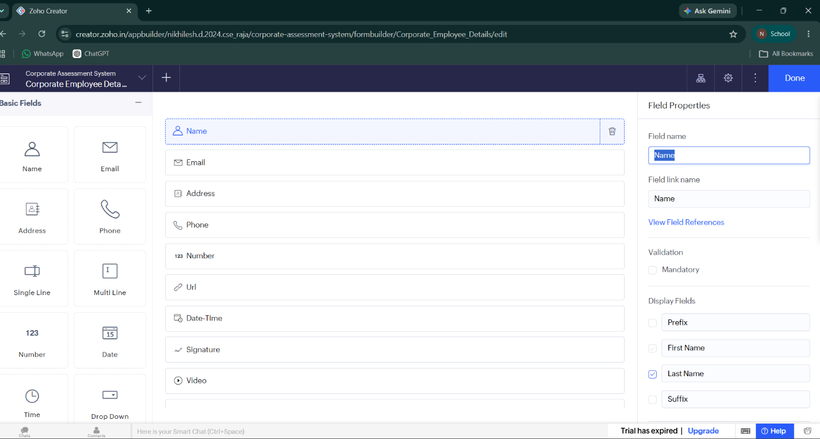Caption: Figure 2.1 – Sample Application Created in Zoho Creator

II) Creating Form, Report and Dashboard
A. Form
A form was created in Zoho Creator to collect and store the required information. The form contains appropriate fields for entering and managing application data. The drag-and-drop interface was used to add and configure the required fields.

B. Report
A report was created to display and organize the data collected through the form. The report provides a structured view of the stored records and makes the information easier to access and analyze.

Caption: Figure 2.2– Report Created in Zoho Creator

C. Dashboard
A dashboard was created to provide a visual representation of the application data. It can contain reports, charts, and other components that help users understand important information quickly. 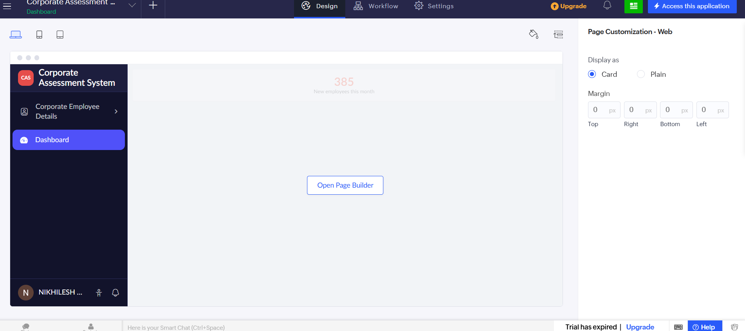

3. Exploring the Platform Architecture and Interface
Develop
The Develop section is used to create and customize the application. It provides options for creating forms, reports, pages, workflows, and other application components. The low-code interface allows applications to be developed using visual tools with minimal programming.
Deploy
The Deploy section is used to make the developed application available to users. It provides options for publishing the application and configuring application access and user permissions. This section helps in making the completed application ready for actual use.

Manage
The Manage section is used to administer and maintain the application. It provides options for managing users, permissions, application settings, and other administrative activities. It helps in maintaining the application after deployment.

Result
Thus, the Zoho Creator platform was successfully explored by creating a sample application and its form, report, and dashboard. The Develop, Deploy, and Manage sections of the platform were also studied, providing an understanding of the basic architecture and interface of a low-code application development platform.

